Presented By

Ambreen Honey 01-135252-015
Moomina Sagheer 01-135252-041
Maryam Akmal 01-135252-036

project
Coffee Shop Website

Coffee Shop Website Project Report
Project Title: Caramel Cloud Coffee – Multi-Page Website
Course / Subject: ICT.
Date: [15-December-25]

1. Introduction
This project is a fully functional, multi-page website created for a fictional coffee shop named Caramel Cloud Coffee.
The goal of the website is to present an attractive and user-friendly online presence where customers can view the coffee menu, explore services, check price lists, learn about the brand, and place orders through an online form.
The website consists of seven interconnected HTML pages:
Home (index.html), Menu, Table (Price List), Order Form, Services, About, and Contact.
Each page is designed with a consistent color theme, professional layout, and smooth navigation to ensure a pleasant user experience.

2. Project Objectives
The main objectives of this website project were:
- To design a clean and responsive user interface.
- To provide complete information about the coffee shop, including menu, pricing, and services.
- To implement a simple navigation system linking all pages.
- To demonstrate the use of HTML, CSS, and responsive design principles.
- To create an online order form for customer interaction.
- To showcase different webpage structures (tables, forms, sections, etc.).

3. Website Structure
The website is divided into seven pages, each responsible for displaying specific information.
1. index.html (Home Page)
- Serves as the welcoming page for visitors.
- Contains the website header, brand name, and navigation bar.
- Highlights the theme and style of the coffee shop.
2. menu.html (Menu Page)
- Displays all available coffee items.
- Organized into categories such as:
  - Coffee Classics
  - Specialty Coffees
  - Beverages
  - Desserts & Snacks
- Uses images and styled sections for improved presentation.
3. table.html (Price List Page)
- Shows all products along with their prices in a styled table format.
- Prices are divided by size (Small, Medium, Large) for coffee items.
- Snacks and beverages have a single fixed price column.
- Uses a consistent brown–coffee color theme.
4. form.html (Order Form Page)
- Contains a functional order form.
- Includes text fields, dropdown menus, radio buttons, or quantity fields (based on your code).
- Allows customers to enter their details and select the coffee they want to order.
- Demonstrates form creation and input handling in HTML.
5. services.html
- Explains all the services offered by the coffee shop.
- May include services like:
  - Dine-in
  - Takeaway
  - Home Delivery
  - Catering
  - Special Coffee Events
- Includes styled sections with headings and descriptions.
6. About.html
- Describes the history, mission, and vision of Caramel Cloud Coffee.
- Introduces the shop’s specialty drinks and brand purpose.
- Helps build trust and connection with customers.
7. Contact.html
- Provides all contact details:
  - Address (e.g., Bahria University, Shangrilla Road, E-8)
  - Phone number
  - Email
- Includes an embedded Google Map showing the shop location.
- Helps customers reach or contact the shop easily.

4. Technologies Used
HTML
- Structure of all web pages
- Headers, paragraphs, images, lists, and tables
- Form elements for user input
CSS
- Styling for layout, color scheme, buttons, tables, headers, and backgrounds
- Use of gradients, shadows, and hover effects
- Responsive design using media queries
- A consistent brown coffee-themed palette across the website

5. Visual Design & Theme
The website follows a coffee-inspired color palette using shades of:
- Caramel Brown
- Cream
- Chocolate Brown
- Beige
Design features include:
- Box shadows for depth
- Rounded borders
- Clean typography
- Hover effects on navigation buttons
- Well-organized sections with spacing and alignment
These elements together create a warm and inviting visual atmosphere suitable for a coffee shop.

6. Navigation System
A navigation bar is placed at the top of every page, including links to:
- Home
- Menu
- Price List
- Order Form
- Services
- About
- Contact
This ensures visitors can move smoothly between all pages.

7. Key Features of the Website
- Multi-page structure with internal linking
- Styled menu and price tables
- Responsive layout for mobile and desktop
- Order form for customer interaction
- Google Map integration
- Professional color theme and visual consistency

Required screenshots:
Website pages:
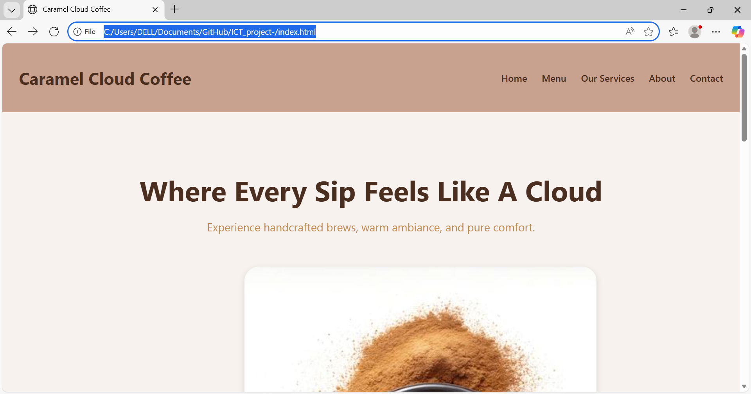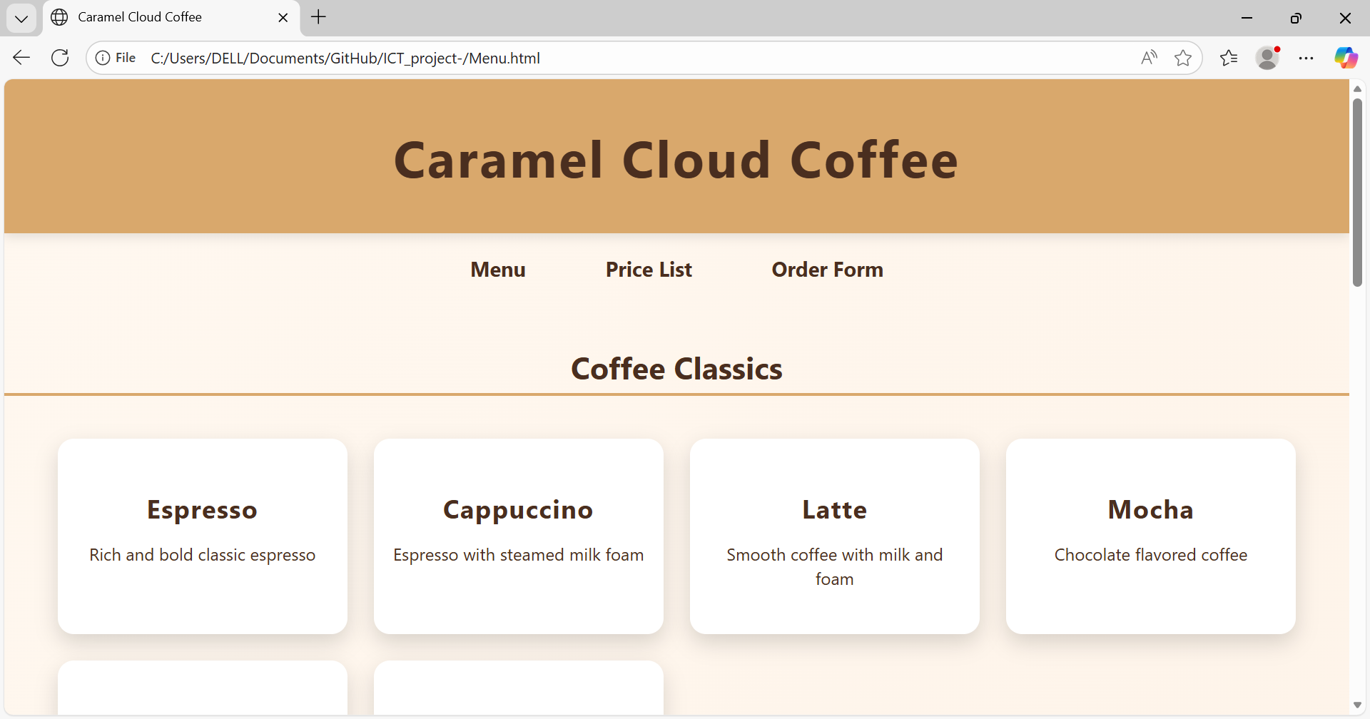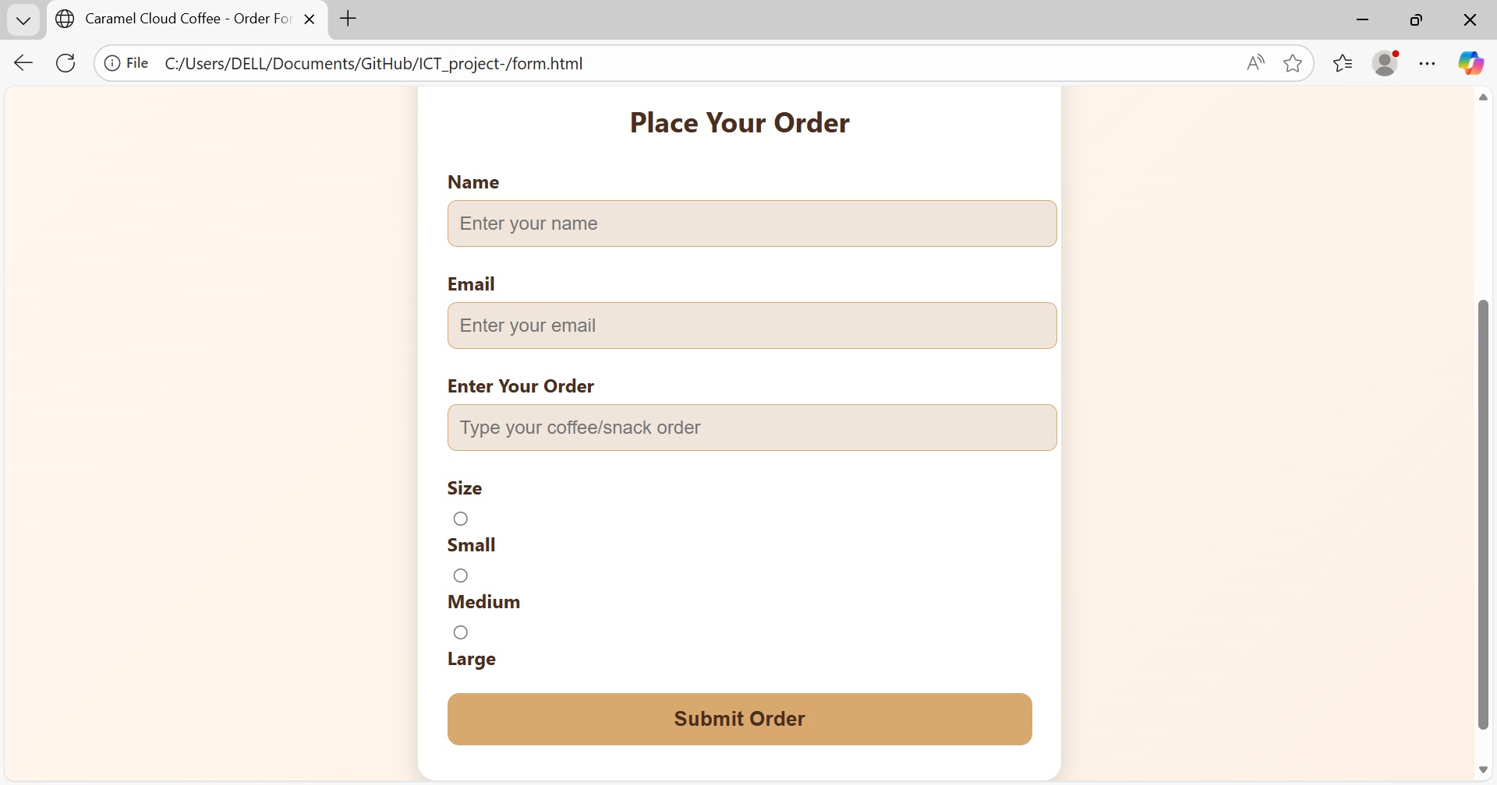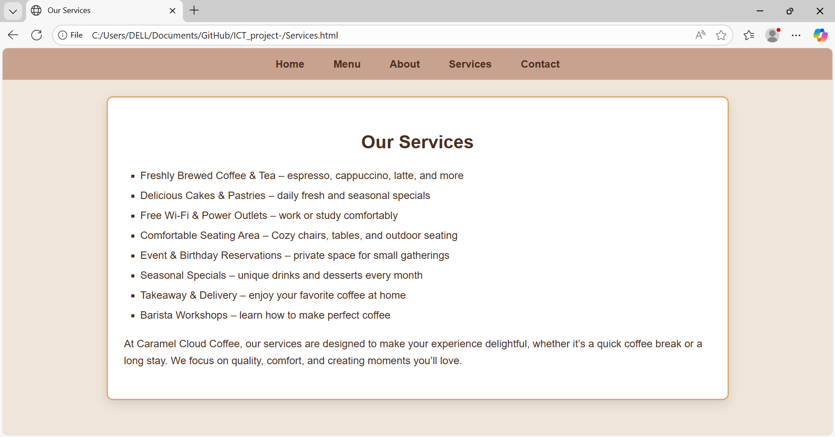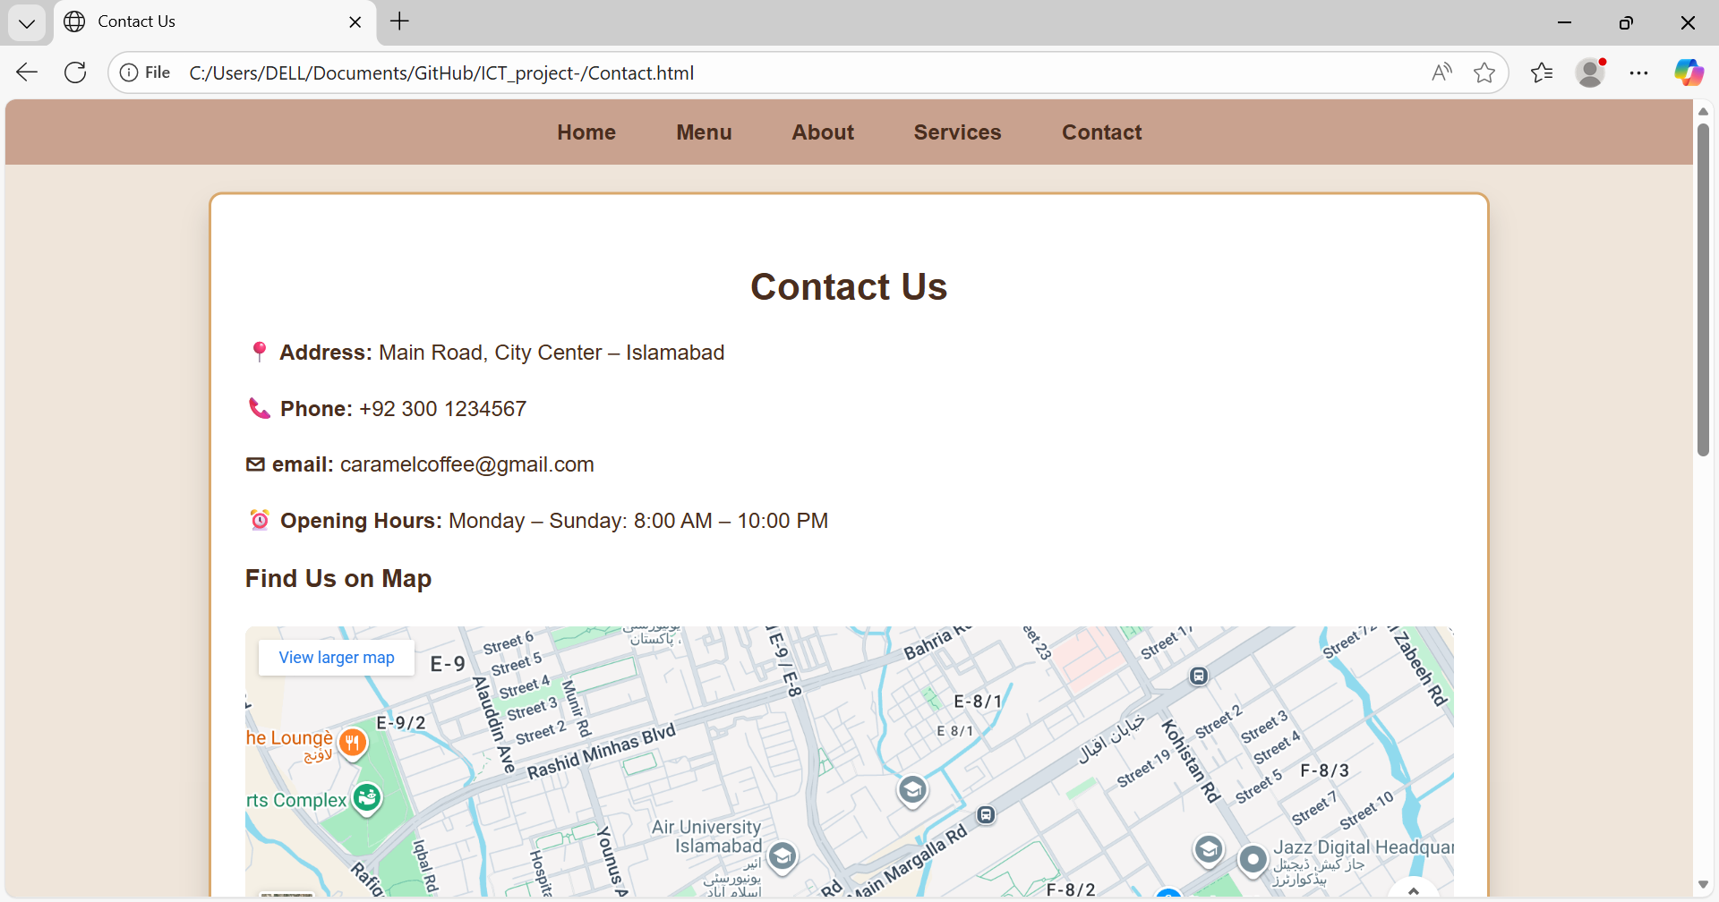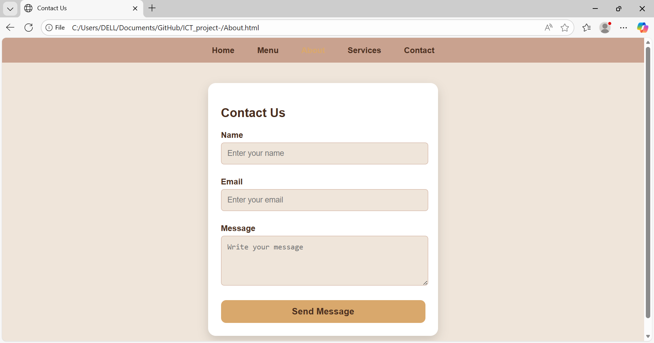
Github Repository:
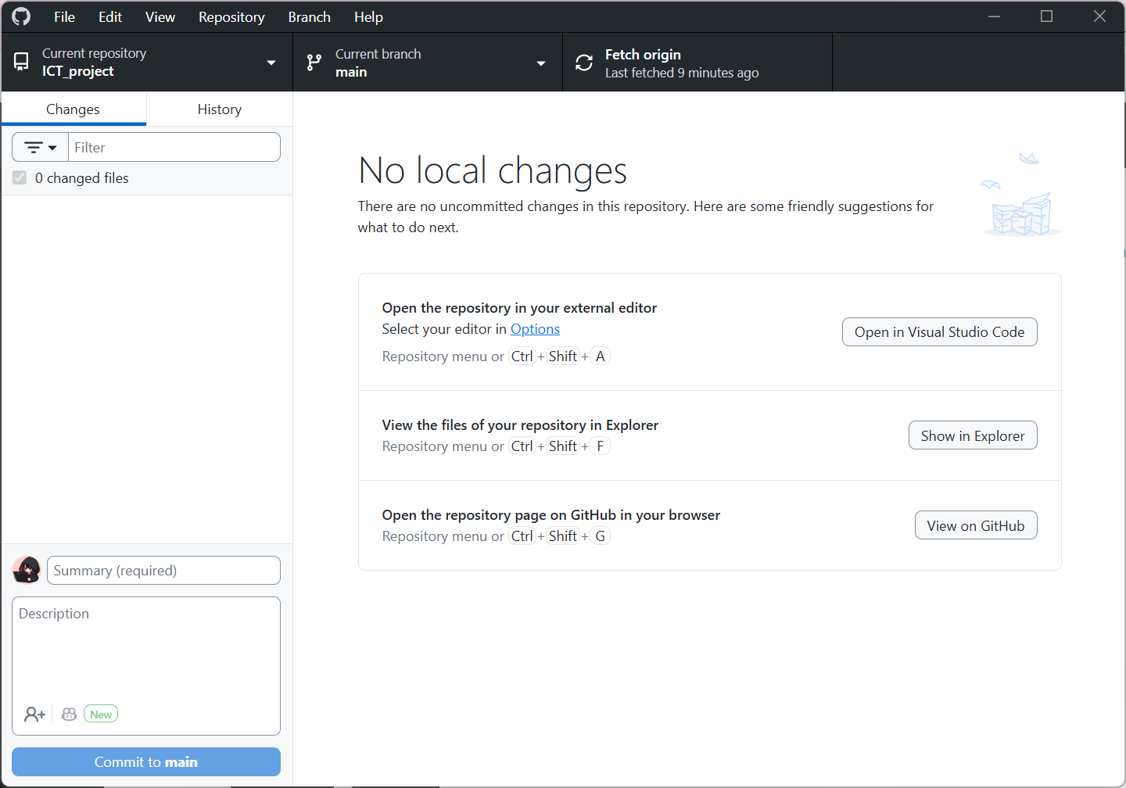
Commits History: 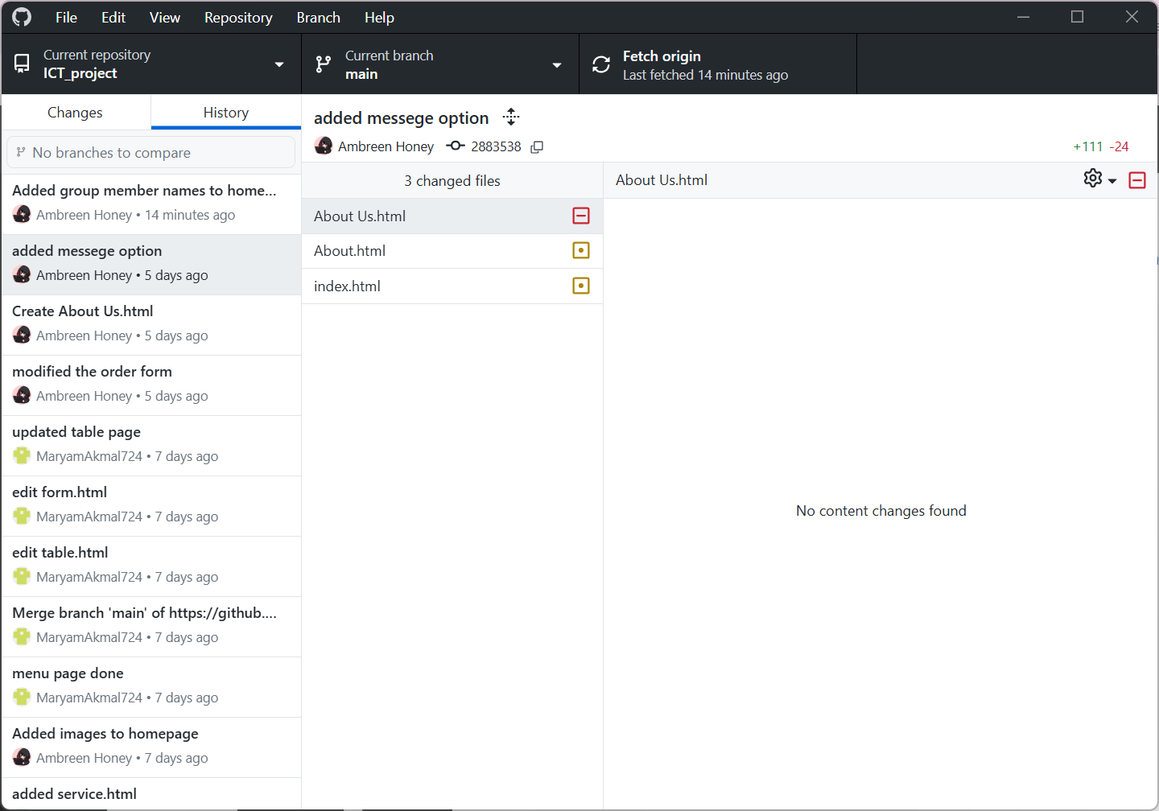
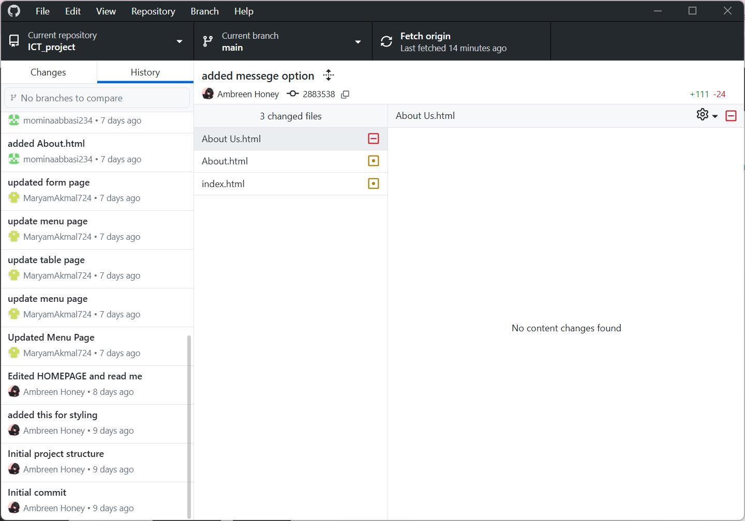
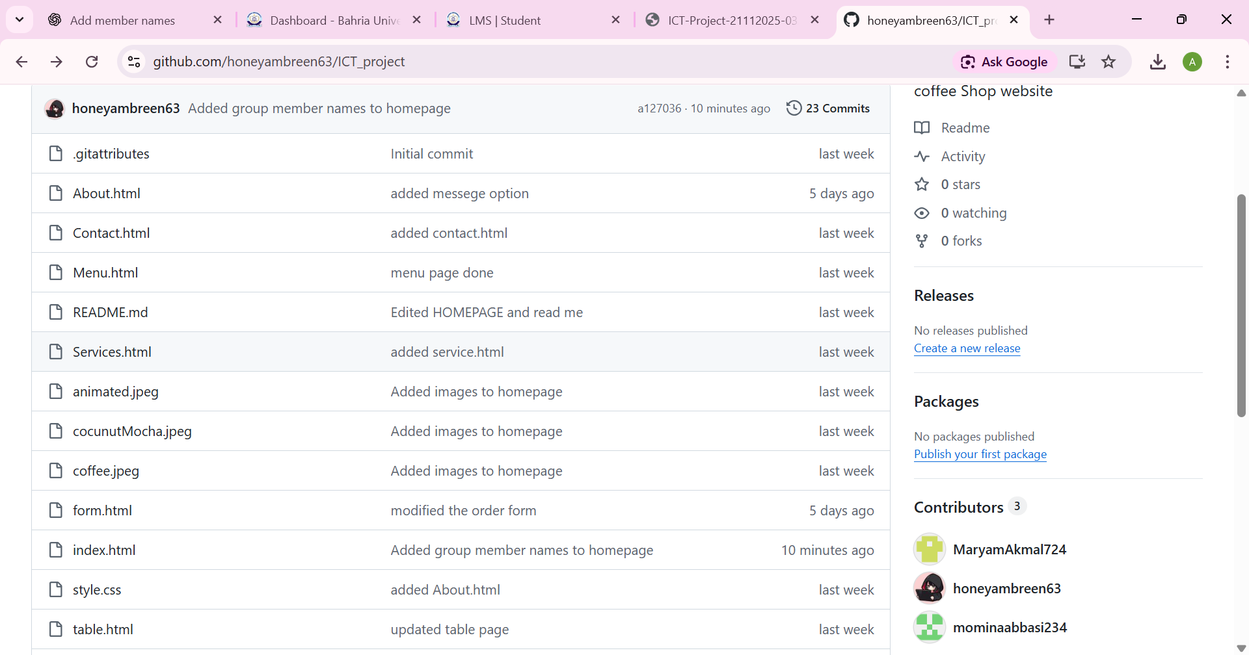
Folder Structure:
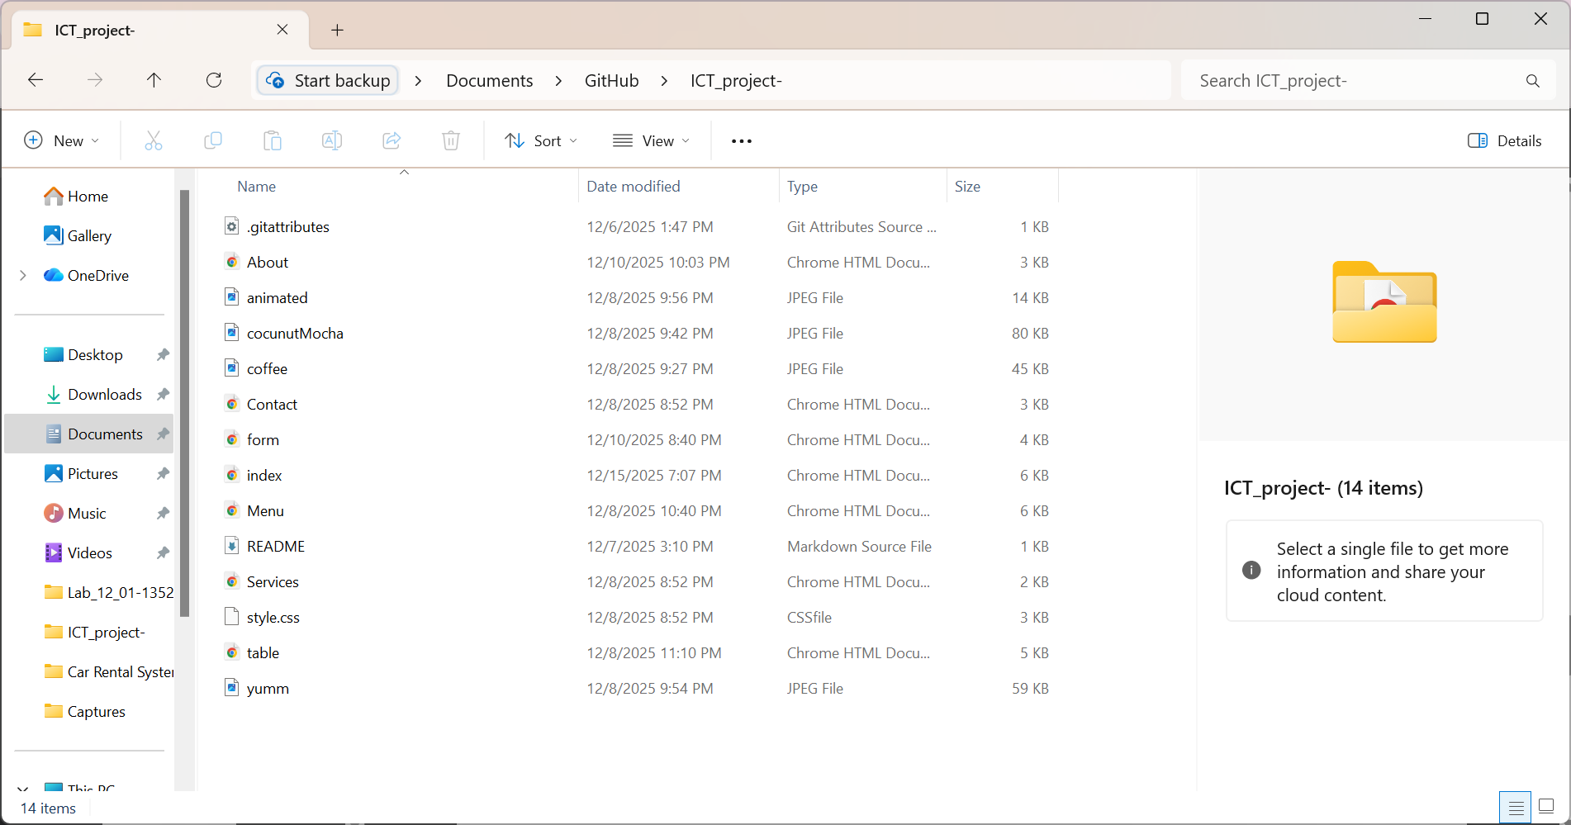

Github pages:
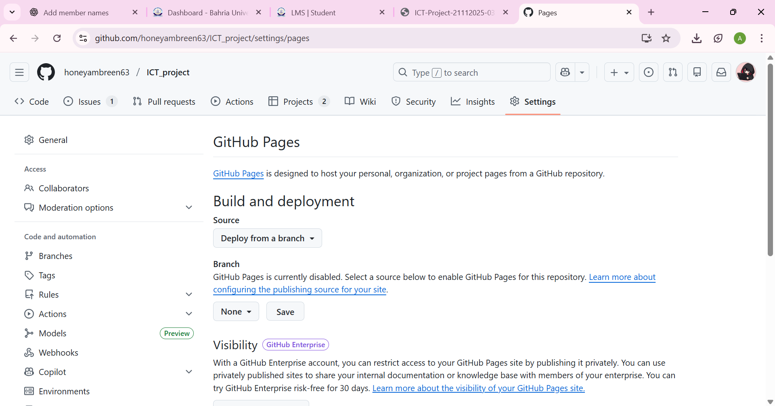
Github Project board:
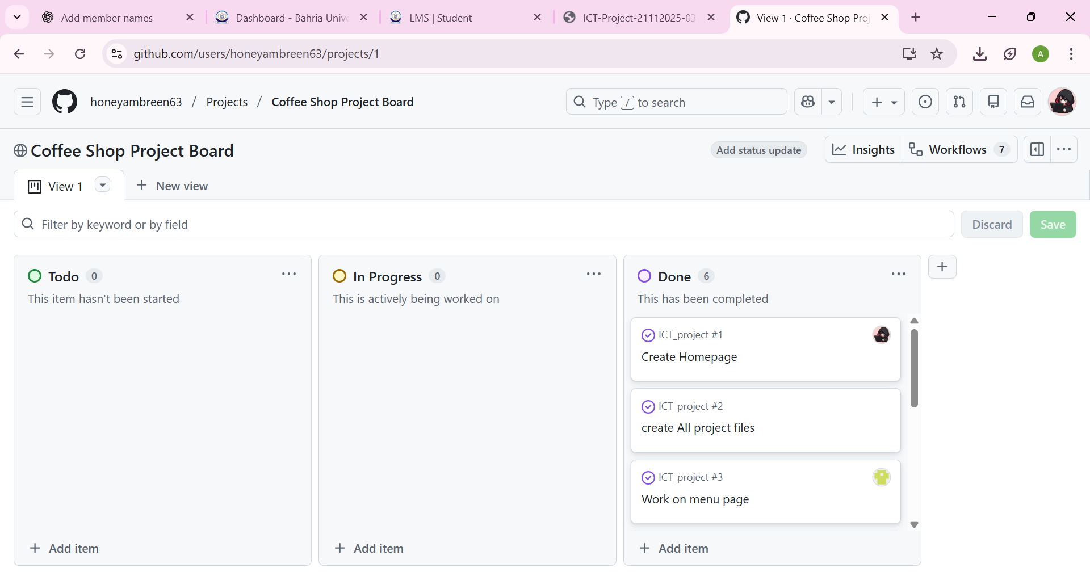
8. Conclusion
The Caramel Cloud Coffee website successfully meets the objectives of the project.
It demonstrates the use of HTML and CSS to create a professional, multi-page website with structured content, stylistic design, and responsive behavior.
The website can be further enhanced in the future by adding:
- JavaScript for form validation
- Image sliders
- A login system
- Online payment integration
Overall, this project showcases strong understanding of web development fundamentals and effective visual design.
Required links:
https://github.com/honeyambreen63/ICT_project
Caramel Cloud Coffee

